SDK and System Resources of
B3VCU

STELS PART NO: 2200302054

Change Index.
Index | Date | Amendment contents | Version | Person
1 | 07 July2022 | First Copy for release | 1.0.1 | Chen Yong
2 | 3 Aug 2022 | Modify by VCU_IDS_V0.2.xlsx requirement | 1.0.2 | Chen Yong

Table of Contents

1 Scope 4
2 System 4
3 Environment 5
3.1 VCU 5
3.2 Programming computer 6
4 B3VCU system resources 6
4.1 External interface 6
4.1.1 CAM UART 6
4.1.2 VDU UART 6
4.1.3 Spare UART 7
4.1.4 Ethernet 7
4.1.5 Keypad 7
4.1.6 Digital GPIO Output 7
4.1.7 SDI Video Input 8
4.1.8 SDI video Output 8
4.1.9 LED 8
4.2 Internal Interface 9
4.2.1 I2C 9
4.2.2 frmbuf_rd 9
4.2.3 mix 9
4.2.4 uhdsdi_tx 9
4.2.5 sdi_anc_tx 10
4.2.6 IIo sensor 10
4.2.7 pdma 10
4.2.8 Reserve memory 10
4.2.9 Watchdog 10
5 Programming 11
5.1 A simple firmware 11
5.1.1 Edit 11
5.1.2 Compile 12
5.1.3 Run firmware 12

1 Scope
This document stipulates SDK -System resources specification procedures for Video Control Unit (abbreviated as VCU B3 here after). This document will be used as a guideline to system resources and programming of VCU B3 in according to the technical specification requirements.

2 System
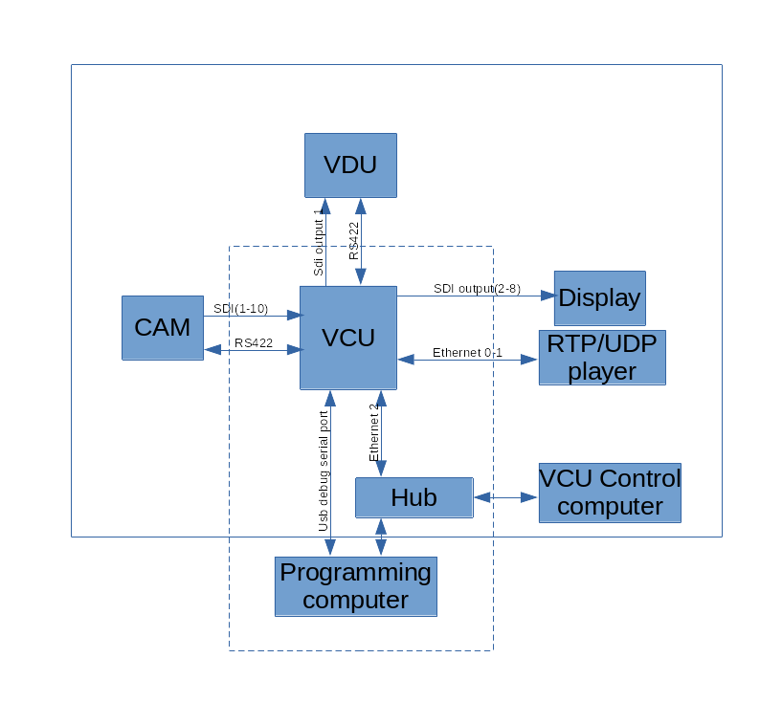

Figure is the full system physical linking. The devices and linking for programming are in the dotted line box.

3 Environment

3.1 VCU
Default setting:
- static IP (192.168.1.254)
- username: root
- password: root
The user can download and upload files to VCU with sftp client software.
The user can control the VCU with the serial port debug application (e.g: teraterm).
The user also can log in and control the VCU with putty or ssh.

3.2 Programming computer
- This computer is for programming the software for the VCU. The Ubuntu (20.04) is required and verified to work.
- This computer has the same subnet IP address with the VCU.
- The user need install the requirement software eg Filezilla(sftp client), GTKTerm(serial debug) or ssh for downloading, uploading and debugging the VCU files.
- The user run sdk.sh(from teamone) to install the sdk compiler.
- <your-sdk-dir>/environment-setup-cortexa72-cortexa53-xilinx-linux includes the environment setup for the compiler. The user need setup the environment of the compiler based on their SDK requirement.

4 B3VCU system resources

External interface

4.1.1 CAM UART
This port is link to the TI camera for the NUC controlling.
Physical link: TIA/EIA-422
Device name: /dev/ttySC0
working mode: Duplex
flow control: no

4.1.2 VDU UART
This port is link to the VDU for the VDU switching command.
Format: TIA/EIA-422
Device name: /dev/ttySC1
working mode: Duplex
flow control: no

4.1.3 Spare UART
Format: TIA-232
Device name: /dev/ttyPS1, /dev/ttySC2, /dev/ttySC3
working mode: Duplex
flow control: no

4.1.4 Ethernet
10/100/1000 BASE-T
- Port 1(eth2): VCU control port. default static IP 192.168.1.254
- Port 2(eth0): VCU RTP video stream port. Default Static IP 192.168.6.254
- Port 3(eth1): VCU RTP video stream port. Default Static IP 192.168.7.254

4.1.5 Keypad
Key No | Gpio port | Key name | Linux code
KEY_DIN_1 | <axi_gpio_0 0> | key1 | KEY_1(2) | Trailer ?
KEY_DIN_2 | <axi_gpio_0 1> | key2 | KEY_2(3) | Reverse Gear
KEY_DIN_3 | <axi_gpio_0 2> | key3 | KEY_3(4) | Forward Gear
KEY_DIN_4 | <axi_gpio_0 3> | key4 | KEY_4(5) | TBD
KEY_DIN_5 | <axi_gpio_0 4> | key5 | KEY_5(6) | TBD
KEY_DIN_6 | <axi_gpio_0 5> | key6 | KEY_6(7) | TBD
KEY_DIN_7 | <axi_gpio_0 6> | key7 | KEY_7(8) | TBD
KEY_DIN_8 | <axi_gpio_0 7> | key8 | KEY_8(9) | TBD

4.1.6 Digital GPIO Output
DO No | Linux GPIO No | Terminal | Description
DO1 | 492 | IR | On/OFF IR
DO2 | 493 | IR | On/OFF IR
DO3 | 494 | TBD
DO4 | 495 | TBD
DO5 | 496 | TBD

4.1.7 SDI Video Input
Device name: /dev/media6 (/dev/video0)
/dev/media7 (/dev/video1)
/dev/media8 (/dev/video2)
/dev/media9 (/dev/video3)
/dev/media0 (/dev/video4)
/dev/media1 (/dev/video5)
/dev/media2 (/dev/video6)
/dev/media3 (/dev/video7)
/dev/media4 (/dev/video8)
/dev/media5 (/dev/video9)

4.1.8 SDI video Output
SDI0 output: frmbuf_rd --> mix -> uhdsdi_tx (‘mix’ can mix video and osd)
SDI1 – SDI7 output: frmbuf_rd->udhsdi_tx. (without osd funciton)
There is a device “sdi_anc_tx” in all output. It can embed timestamp into the SDI signal.
all devices refer to internal interface:
frmbuf_rd: refer to 4.2.2
mix: refer to 4.2.3
uhdsdi_tx: refer to 4.2.4
sdi_anc_tx: refer to 4.2.5

4.1.9 LED
LED | Linux GPIO No | Description
Green | 458 | Normal Status
Red | 459 | BIT error

4.2 Internal Interface

4.2.1 I2C
device name: /dev/i2c-0
slave chip: mb85rc256vfp slave address: 0x50
description: log data storage

4.2.2 frmbuf_rd
Address: sdi0(0xb02d0000) sdi1(0xb02f0000) sdi2(0xb0310000) sdi3(0xb0330000) sdi4(0xb03a0000) sdi5(0xb03c0000) sdi6(0xb03e0000) sdi7(0xb0400000)
Support Format: Y_UV10, Y_UV8
refer to document (pg278-v-frmbuf.pd) provided by Xilinx

4.2.3 mix
Address: 0xb02e0000
Primary video format: YUV4:2:2 10bits
Overlay layer1 format: BGRA8
Maximum resolution: 1920x1080
refer to document (pg243-v-mix.pdf) provided by Xilinx

4.2.4 uhdsdi_tx
Address: sdi0(0xa0040000) sdi1(0xa0060000) sdi2(0xa0080000) sdi3(0xa00a0000) sdi4(0xa0100000) sdi5(0xa0120000) sdi6(0xa0140000) sdi7(0xa0160000)
Mode: 3G SDI 10bits
format: NV16_10LE32
refer to document (pg289-v-smpte-uhdsdi-tx-ss.pdf) provided by Xilinx

4.2.5 sdi_anc_tx
Address: sdi0(0xa01c0000) sdi1(0xa01d0000) sdi2(0xa01e0000) sdi3(0xa01f0000) sdi4(0xa0200000) sdi5(0xa0210000) sdi6(0xa0220000) sdi7(0xa0230000)
data format: 64bits unsigned interger. Microseconds of the epoch time.

4.2.6 IIo sensor
CPU:/sys/bus/iio/devices/iio\:device0
Power Current Sensor:/sys/bus/iio/devices/iio\:device1

4.2.7 pdma
It is a user interface to transfer a DAM address of the user space to the physical address.
Device: /dev/pdma0
ioctl cmd: 0
ioctl parameters: struct{guint64 param_in; guint64 param_out}
param_in: the dma user-space address.
param_out: the dma physical address

4.2.8 Reserve memory
reserve memory physical address:0x70000000
reserve memory size: 0xff00000

4.2.9 Watchdog
Device: /dev/watchdog0, /dev/watchdog1
watchdog0 is controlled by OS.
Watchdog1 can be controlled by the user.

5 Programming

5.1 A simple firmware

5.1.1 Edit
Install Atom as the SDK editor. Install Atom requirement plugin.
Create the Project Folder and Add this project folder into the Atom.
create a new file ‘Makefile’ and a folder ‘src’ in this project folder.
Create a source file ‘main.c’ in the folder ‘src’.
edit Makefile:
TARGET := $(notdir $(CURDIR))
CSOURCES := $(wildcard src/*.c)
COBJECTS := $(CSOURCES:%.c=%.o)
CPPSOURCES := $(wildcard src/*.cpp)
CPPOBJECTS := $(CPPSOURCES:%.cpp=%.o)

CFLAGS := -O
LDFLAGS :=
LIBS :=
.PHONY: $(TARGET)

$(TARGET): $(COBJECTS) $(CPPOBJECTS)
$(CXX) -o $@ $^ $(LDFLAGS) $(LIBS)

$(COBJECTS): %.o: %.c
$(CC) $(CFLAGS) -o $@ -c $<

$(CPPOBJECTS): %.o: %.cpp
$(CXX) $(CFLAGS) -o $@ -c $<
clean:
rm -rf *~ .dep $(COBJECTS) $(CPPOBJECTS) $(TARGET)

edit the main.c:
#include <stdio.h>

int main()
{
printf(“hello world!\n”);
return 0;
}

5.1.2 Compile
Open Terminal and Go to your project folder. Run “make”.
Then you get a executable file ‘<your-project-folder>’ in <your-project-folder>.

5.1.3 Run firmware
- Download the executable file to /usr/local/bin in the VCU with the sftp client software
- Open GTKTerm and connect to the VCU with the USB debug port.
- (e.g /dev/ttyUSB0)
- Disable the original VCU firmware in /etc/init.d/loaduserapp.sh and reboot the VCU
- go to the folder /usr/local/bin and run your application

